**Network Settings**

**Activated/Selected Network**

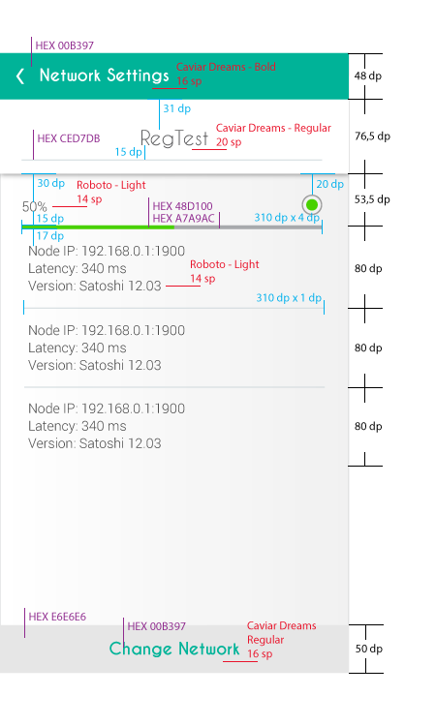

**Select a Network**

